

RFC 0115 - Persistent Storage Management for Vehicle Device

Confidential, Draft
20 Pages

Abstract

Document Information

Table of Contents
0 Document Information 2
0.1 Table of Contents 2
0.2 Terminology and Document Conventions 4
0.3 Revision History 4
1 Introduction 4
2 Application Domain 4
2.1 Persistent Storage Management domain for Vehicle Device 5
2.2 Entities 5
3 Problem Description 5
4 Requirements 6
4.1 High Level Functional Requirements 6
4.1.1 Security 6
4.1.2 User Specific Data Management 6
4.1.3 User Storage Management 6
4.1.4 Synchronization Related 6
4.2 Overall System Requirements 7
4.3 System Elements 7
4.3.1 Telematics Terminal 7
4.3.2 Telematics Server 7
4.3.3 Data model 7
5 Technical Solution 8
5.1 Overview 8
5.2 Sequence Diagram 8
5.2.1 User Storage Management 8
5.2.2 Configuration Management per Each User 9
5.2.3 PIMS Data and Personal S/W specific configuration data Management 10
5.3 Class Diagram 11
6 Java API 11
6.1 Interface Storage 11
6.1.1 getMaxStorageSize 12
6.1.2 getCurrentStorageSize 12
6.1.3 getAvailable 12
6.2 Class PersistentStorage 12
6.2.1 USER_PROFILE 13
6.2.2 USER_PIM 13
6.2.3 USER_PIM_DIR 13
6.2.4 USER_DESTINATION 14
6.2.5 USER_DESTINATION_DIR 14
6.2.6 USER_PRIVATE 14
6.2.7 USER_PRIVATE_DIR 14
6.2.8 getInstance 14
6.2.9 getMaxStorageSize 14
6.2.10 getCurrentStorageSize 14
6.2.11 getAvailable 15
6.3 Class PersistentStorageException 15
6.3.1 PersistentStorageException 15
6.3.2 PersistentStorageException 16
6.4 Class UserStorage 16
6.4.1 getPath 16
6.4.2 getUserHome 17
6.4.3 getMaxStorageSize 17
6.4.4 setMaxStorageSize 17
6.4.5 getCurrentStorageSize 17
6.4.6 getAvailable 17
7 Alternatives 18
8 Security Considerations 18
9 Document Support 18
9.1 References 18
9.2 Author’s Address 18
9.3 Acronyms and Abbreviations 19
9.4 End of Document 19

Terminology and Document Conventions
The key words "MUST", "MUST NOT", "REQUIRED", "SHALL", "SHALL NOT", "SHOULD", "SHOULD NOT", "RECOMMENDED", "NOT RECOMMENDED", "MAY" and "OPTIONAL" in this document are to be interpreted as described in [1].
Source code is shown in this typeface.

Revision History
The last named individual in this history is currently responsible for this document.

Revision | Date | Comments
Initial  R1.1 | 2006.01.16 | Document Creation
R1.2 | 2006.03.04 | Chapter 7 Considered Alternatives are written by considering the comments issued in Sophia-Antipolis meeting(Jan. 19)

Introduction

This document describes how to manage persistent storage to several Users who are using a Telematics Terminal in their car. The main focus of this storage is to manage configuration data.
As multiple users will be using a Telematics Terminal, it is clear that for each user, the data they are manipulating
needs to be made persistent. Moreover the user should only be able to access the data he is authorized for.
It is to be expected that multiple applications will use similar types of data (e.g. address data for both a phone application and navigation services). Having a standardized data model for the persistent storage will make access and storage more efficient.

Application Domain

Persistent Storage Management domain for Vehicle Device

This data model architecture is designed to manage the persistent storage per each User.

As several Users may use the same Telematics Terminal, there is a need for managing the storage that contains each User’s PIMS Data, S/W specific configuration data,, security information, etc.

The persistent storage management system will be related to RFC 9: Preferences dealing with managing user preference data. It will be also related to RFC 10: User Admin when it requires user specific persistent storage.

Entities

Telematics Terminal
The Telematics Terminal is a terminal device in vehicle which is used to the telematics service.
It can be also a mobile phone or PDA, etc.
Telematics Server
The Telematics Server is a Telematics Server system which provides various telematics services.
User
The User is a driver or a fellow passenger in vehicle who uses the telematics service.
Administrator
The Administrator is a telematics system Administrator in the Telematics Server side.
PIMS Data
Personal Information Management Systems Data (e.g. address book, schedule, preference destination, etc)

Problem Description
Typically several users will use, personalized, telematics service in a vehicle. In this case, the information of each user(S/W specific configuration data) should be handled correctly: a user should only be able to access the data he is authorized for. Also many applications may use the type of data of a User. If these applications manage the data separately, it is inefficient. Therefore a standardized interface is needed to access S/W specific and user specific data.
The User Admin service provides APIs to manage users, and the Preference service provides APIs to maintain the user preference data. These two services or other services may need overall persistent storage management service when getting available persistent storage space for example.

Requirements

High Level Functional Requirements

Security
- The User must be authenticated to use his persistent storage.
- The User must be authorized to manage another User’s persistent storage.
- All data communications between the Telematics Terminal and the Telematics Server must be secure.

User Specific Data Management
- The persistent management system may provide independent storage space in the Telematics Terminal for each User.
- It must be possible to store and retrieve PIMS data per User.
- It must be possible to store and retrieve S/W specific configuration data per User.
- It must be possible to store and retrieve user configuration data per User.
- It must be possible to store and retrieve security data per User.

User Storage Management
- It must be possible to create a limited amount of storage space, or change this limited amount of storage space per User.
- It must be possible to know the available amount of persistent storage space.
- It must be possible to know the amount of space used by the User.

Synchronization Related
- The User specific data should be able to be synchronized with a Telematics Server or other mobile devices, e.g. mobile phone, PDA.

Overall System Requirements
- The persistent storage management system should be able to support a multi-user environment in the Telematics Terminal.

System Elements

Telematics Terminal
- Independent storage may be needed for each User( e.g. family members)
- Each User should be authenticated to use the vehicle device by using convenient methods such as IC cards.
- A standardized interface that accesses current driver’s storage is required for the personalized applications which use PIMS data
- (The PIMS data in the terminal can be synchronized directly with other mobile devices, e.g. mobile phone, PDA.)

Telematics Server
- The PIMS data in the Telematics Server may be synchronized with the telematics terminal but also with the other devices, e.g. mobile phone, PDA, home server.

Data model
The persistent storage management system can have a data model as follows.
    - PIMS Data
  - Address book : refer the OMA vCard
  - Schedule : refer the OMA vCalendar
  - Destination preference: One of the specialized information in telematics that is used for the route guidance and navigation. In this case, new object type may be defined which is not in the OMA vObject. For example, it can be called ‘vDestination’.

- User specific vehicle Information
  - Preferred FM band information
  - Seat position information for the individual User

- S/W specific configuration Data
- Preference URL : be used on browser application and refer the OMA vBookmark
- Each of applications can have information specialized on person

- Security Information
- Information used only for Telematics Terminal and does not have to be synchronized with the Telematics Server, (e.g. credential data)

Technical Solution

Overview
The architecture of Persistent Storage Management for Vehicle Device is based on DMT model in OMA DM and “RFC 10 – UserAdmin”.

Sequence Diagram

User Storage Management

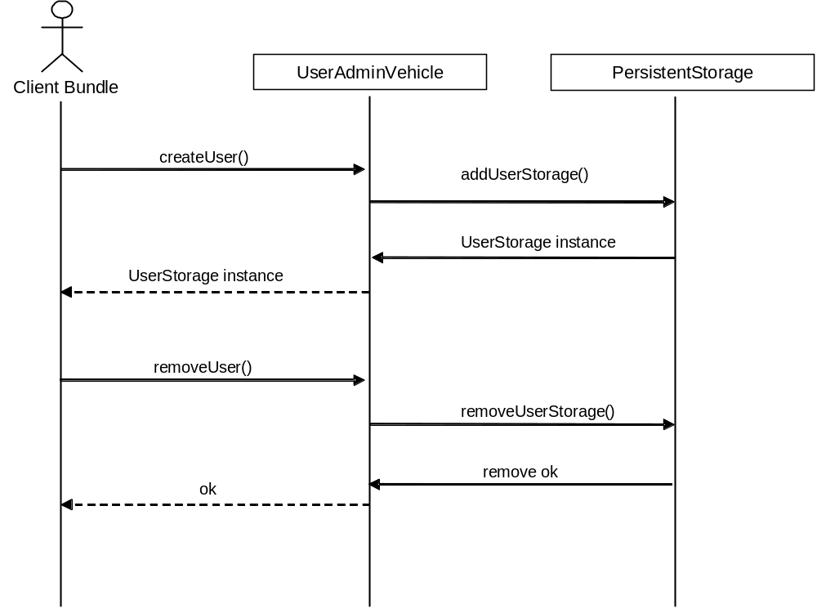

Figure1. User Storage Management

- The UserAdminVehicle interface is inherited from UserAdmin(RFC 10)
- The Client Bundle can get the user’s home directory, available space through the UserStorage class.

The client bundle calls UserAdminVehicle’s createUser() method to create a new user, UserAdminVehicle creates a new user, then request to the PersistentStorage service for creating a new user storage.
The same manner, when the client bundle calls UserAdminVehicle’s removeUser() method to remove an existing user, UserAdminVehicle removes the user and requests to the PersistentStorage service for removing the user’s storage.

Configuration Management per Each User
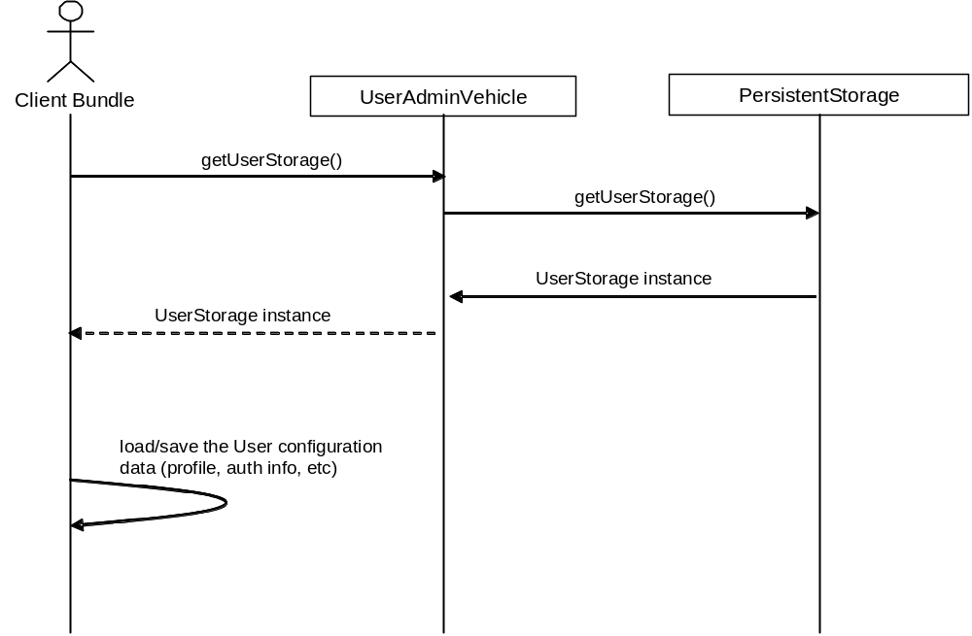

Figure2. Configuration Management per Each User

- The UserAdminVehicle interface is inherited from UserAdmin(RFC 10)

First, the client bundle calls UserAdminVehicle’s getUserStorage() method.
The UserAdminVehicle calss PersistentStorage’s getUserStorage() method.
The client bundle can get the User’s home directory and load/save the user’s properties.

PIMS Data and Personal S/W specific configuration data Management
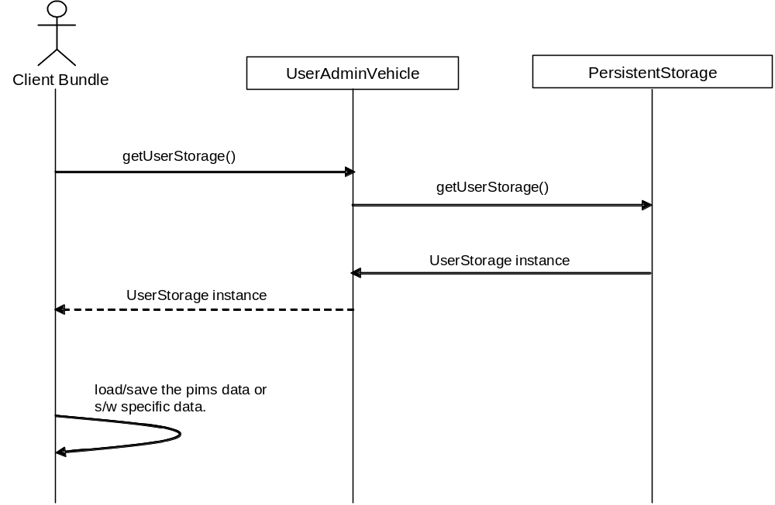

Figure3. PIMS Data and Personal S/W specific configuration data Management
- The UserAdminVehicle interface is inherited from UserAdmin(RFC 10)
- The PersistentStorage class only provides the directory location and space; The PIMS data can be saved or loaded in vObject or any kind of format.

To retrieve or update the PIMS data or S/W specific configuration data, the client bundle need to get the user specific persistent storage first.
The client bundle calls UserAdminVehicle’s getUserStorage() method to get the location of user specific storage.
And the UserAdmin requests to the PersistentStorage for the user’s persistent storage.
The client bundle can load/save the PIMS data or S/W specific configuration data from/to the user’s storage.

Class Diagram
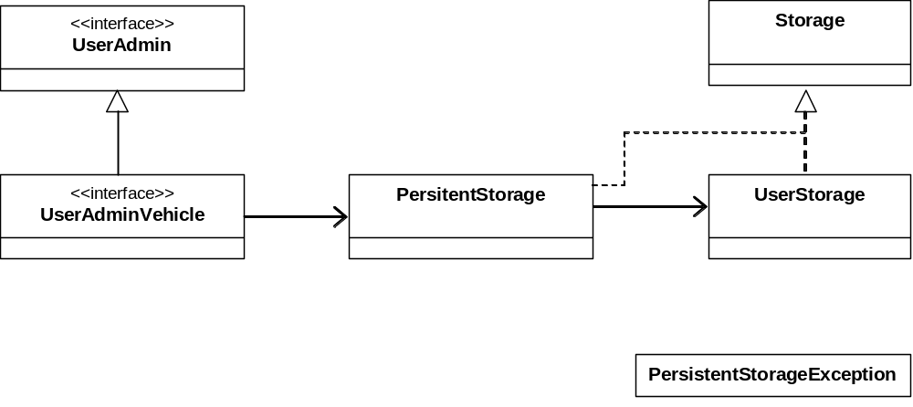

Figure4. Class Diagram

Java API

Interface Storage
All Known Implementing Classes:
PersistentStorage, UserStorage

public interface Storage
Interface for managing Persistent Storage

Method Summary
long | getAvailable()  return available storage size if return value is -1, It means 'unlimted'
long | getCurrentStorageSize()  return using storage size
long | getMaxStorageSize()  return max size of storage if return value is -1, It means 'unlimted'

Method Detail

getMaxStorageSize
public long getMaxStorageSize()
return max size of storage if return value is -1, It means 'unlimted'
Returns:
storage size

getCurrentStorageSize
public long getCurrentStorageSize()
return using storage size
Returns:
using storage size

getAvailable
public long getAvailable()
return available storage size if return value is -1, It means 'unlimted'
Returns:
available storage size

Class PersistentStorage
java.lang.Object
vehicle.ps.PersistentStorage
All Implemented Interfaces:
Storage

public class PersistentStorage
extends java.lang.Object
implements Storage
Manangement class for PersistentStorage

Field Summary
static int | USER_DESTINATION  user destination data location
static java.lang.String | USER_DESTINATION_DIR  user destination dir
static int | USER_PIM  user pim data location
static java.lang.String | USER_PIM_DIR  user pim directory
static int | USER_PRIVATE  user private data location
static java.lang.String | USER_PRIVATE_DIR  user private data dir
static int | USER_PROFILE  user profile location

Method Summary
Long | getAvailable()  total disk space available
Long | getCurrentStorageSize()  total using disk space for all users
static PersistentStorage | getInstance()  return PersistentStorage instance
Long | getMaxStorageSize()  Maximum storage size, unlimted

Methods inherited from class java.lang.Object
equals, getClass, hashCode, notify, notifyAll, toString, wait, wait, wait

Field Detail

USER_PROFILE
public static final int USER_PROFILE
user profile location
See Also:
Constant Field Values

USER_PIM
public static final int USER_PIM
user pim data location
See Also:
Constant Field Values

USER_PIM_DIR
public static final java.lang.String USER_PIM_DIR
user pim directory
See Also:
Constant Field Values

USER_DESTINATION
public static final int USER_DESTINATION
user destination data location
See Also:
Constant Field Values

USER_DESTINATION_DIR
public static final java.lang.String USER_DESTINATION_DIR
user destination dir
See Also:
Constant Field Values

USER_PRIVATE
public static final int USER_PRIVATE
user private data location
See Also:
Constant Field Values

USER_PRIVATE_DIR
public static final java.lang.String USER_PRIVATE_DIR
user private data dir
See Also:
Constant Field Values
Method Detail

getInstance
public static PersistentStorage getInstance()
return PersistentStorage instance
Returns:
PersistentStorage

getMaxStorageSize
public long getMaxStorageSize()
Maximum storage size, unlimted
Specified by:
getMaxStorageSize in interface Storage
Returns:
-1

getCurrentStorageSize
public long getCurrentStorageSize()
total using disk space for all users
Specified by:
getCurrentStorageSize in interface Storage
Returns:
total space, if error occurs, return -1

getAvailable
public long getAvailable()
total disk space available
Specified by:
getAvailable in interface Storage
Returns:
-1 (unlimted)

Class PersistentStorageException
java.lang.Object
java.lang.Throwable
java.lang.Exception
vehicle.ps.PersistentStorageException
All Implemented Interfaces:
java.io.Serializable

public class PersistentStorageException
extends java.lang.Exception
Exception for PersistentStorage
See Also:
Serialized Form

Constructor Summary
PersistentStorageException()
create PersistentStorageException with no message
PersistentStorageException(java.lang.String message)
create PersistentStorageException with message

Methods inherited from class java.lang.Throwable
fillInStackTrace, getCause, getLocalizedMessage, getMessage, getStackTrace, initCause, printStackTrace, printStackTrace, printStackTrace, setStackTrace, toString

Methods inherited from class java.lang.Object
equals, getClass, hashCode, notify, notifyAll, wait, wait, wait

Constructor Detail

PersistentStorageException
public PersistentStorageException()
create PersistentStorageException with no message

PersistentStorageException
public PersistentStorageException(java.lang.String message)
create PersistentStorageException with message
Parameters:
message - detail message

Class UserStorage
java.lang.Object
vehicle.ps.UserStorage
All Implemented Interfaces:
Storage

public class UserStorage
extends java.lang.Object
implements Storage
Mananging class for user specific storage

Method Summary
long | getAvailable()  return available storage size
long | getCurrentStorageSize()  return current using storage size
long | getMaxStorageSize()  return maximum user storage size
java.lang.String | getPath(int location)  return absolute path of current user's profile, pim data, destination data, private data location.
java.lang.String | getUserHome()  return user home directory
void | setMaxStorageSize(long size)  setting maximum storage size

Methods inherited from class java.lang.Object
equals, getClass, hashCode, notify, notifyAll, toString, wait, wait, wait

Method Detail

getPath
public java.lang.String getPath(int location)
throws PersistentStorageException
return absolute path of current user's profile, pim data, destination data, private data location.
Parameters:
location -
Returns:
absoulte path
Throws:
java.lang.IllegalArgumentException - if argument does not match USER_PROFILE, USER_PIM, USER_DESTINATION, USER_PRIVATE
PersistentStorageException

getUserHome
public java.lang.String getUserHome()
return user home directory
Returns:
user Home directory

getMaxStorageSize
public long getMaxStorageSize()
return maximum user storage size
Specified by:
getMaxStorageSize in interface Storage
Returns:
user storage size

setMaxStorageSize
public void setMaxStorageSize(long size)
setting maximum storage size
Parameters:
size -
Throws:
java.lang.IllegalArgumentException - if size less than 0 or equal to zero

getCurrentStorageSize
public long getCurrentStorageSize()
return current using storage size
Specified by:
getCurrentStorageSize in interface Storage
Returns:
storage size

getAvailable
public long getAvailable()
return available storage size
Specified by:
getAvailable in interface Storage
Returns:
available storage size

Considered Alternatives
This RFC has some overlap with other RFCs as follows. Therefore this RFC should be revised drastically suggesting new points which are more vehicle-specific and escape the overlaps.

RFC115 subparts | Other RFCs
3.1 User Storage Management | RFC10 – User Management API  Interface org.osgi.service.useradmin.UserAdmin  Role createRole(String name)  User getUser(String filter)  Boolean removeRole(String name)  Interface Org.osgi.service.useradmin.Group  boolean addMember(Role role)  boolean removeMember(Role role)
3.2 Configuration Management per Each User | RFC9 – Preferences API  PreferenceService.getUserPreferences(String name)
3.3 PIMS Data and Personal S/W specific configuration data Management | RFC9 – Preferences API  Interface Preferences consist of the following methods.  String get(String key, String def)  String getByteArray(String key, def)  void put (String key, String value)  void putByteArray(String key, byte[] value)

Security Considerations

Document Support

References
- Bradner, S., Key words for use in RFCs to Indicate Requirement Levels, RFC2119, March 1997.
- Software Requirements & Specifications. Michael Jackson. ISBN 0-201-87712-0
- vObject Minimum Interoperability Profile, OMA BAC
- RFC 9 - Preferences, OSGi Alliance
- RFC 10 - User Admin, OSGi Alliance

Author’s Address

Name | Kyong-Ho Kim
Company | ETRI, TelematicsUSN Research Division
Address | 161 Gajung-dong, Yusong-gu, Daejon, Korea
Voice | +82-42-869-1634
e-mail | kkh@etri.re.kr

Acronyms and Abbreviations

End of Document

